Treponema pallidum
The spirochetes are a large, heterogeneous group of spiral, motile bacteria. One family (Spirochaetaceae) of the order Spirochaetales consists of two genera whose members are human pathogens, Borrelia and Treponema .
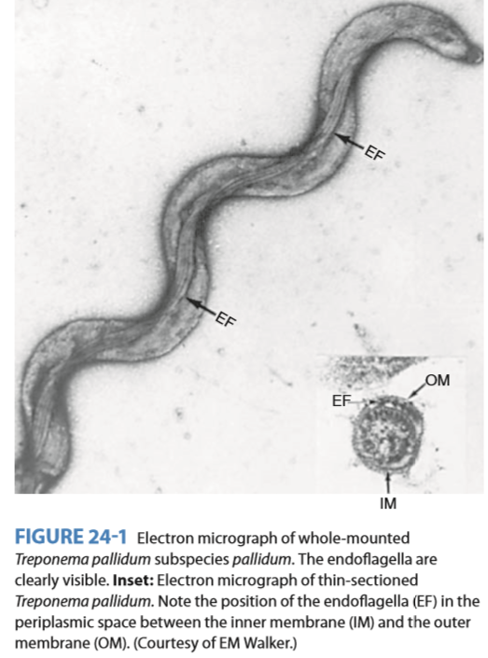
The spirochetes have many structural characteristics in common, as typified by Treponema pallidum (Figure 24-1). They are long, slender, helically coiled, spiral or corkscrewshaped bacilli. T pallidum has an outer sheath or glycosaminoglycan coating. Inside the sheath is the outer membrane, which contains peptidoglycan and maintains the structural integrity of the organisms. Endoflagella (axial filaments) are the flagella-like organelles in the periplasmic space encased by the outer membrane. The endoflagella begin at each end of the organism and wind around it, extending to and overlapping at the midpoint. Inside the endoflagella is the inner membrane (cytoplasmic membrane) that provides osmotic stability and covers the protoplasmic cylinder. A series of cytoplasmic tubules (body fi brils) are inside the cell near the inner membrane. Treponemes reproduce by transverse fission. Treponema pallidum causes Syphilis.

- Pathogenesis
Acquired Syphilis
Natural infection with T pallidum is limited to the human host. Human infection is usually transmitted by sexual contact, and the infectious lesion is on the skin or mucous membranes of genitalia. In 10–20% of cases, however, the primary lesion is intrarectal, perianal, or oral. It may be anywhere on the body.
T pallidum can probably penetrate intact mucous membranes, or the organisms may enter through a break in the epidermis
- Transmission
Spirochetes multiply locally at the site of entry, and some spread to nearby lymph nodes and then reach the bloodstream. Within 2–10 weeks after infection, a papule develops at the site of infection and breaks down to form an ulcer with a clean, hard base (“hard chancre”). The inflammation is characterized by a predominance of lymphocytes and plasma cells. This “primary lesion” always heals spontaneously, but 2–10 weeks later, the “secondary” lesions appear.
- Symptoms
Syphilis consist of a red maculopapular rash anywhere on the body, including the hands and feet, and moist, pale papules (condylomas) in the anogenital region, axillae, and mouth. The patient may also have syphilitic meningitis, chorioretinitis, hepatitis, nephritis (immune complex type), or periostitis. The secondary lesions also subside spontaneously. Both primary and secondary lesions are rich in spirochetes and are highly infectious. Contagious lesions may recur within 3–5 years after infection, but thereafter the individual is not infectious. Syphilitic infection may remain subclinical, and the patient may pass through the primary or secondary stage (or both) without symptoms or signs yet develop tertiary lesions.
Congenital Syphilis- A pregnant woman with syphilis can transmit T pallidum to the fetus through the placenta beginning in the 10th–15th weeks of gestation. Some of the infected fetuses die, and miscarriages result; others are stillborn at term. Others are born live but develop the signs of congenital syphilis in childhood, including interstitial keratitis, Hutchinson’s teeth, saddlenose, periostitis, and a variety of central nervous system anomalies. Adequate treatment of the mother during pregnancy prevents congenital syphilis. The reagin titer in the blood of the child rises with active infection but falls with time if antibody was passively transmitted from the mother. In congenital infection, the child makes immunoglobulin M (IgM) antitreponemal antibody.

- Prophylaxis
Penicillin in concentrations of 0.003 U/mL has definite treponemicidal activity, and penicillin is the treatment of choice. Syphilis of less than 1 year’s duration is treated by a single injection of benzathine penicillin G. In older or latent syphilis, benzathine penicillin G intramuscularly is given three times at weekly intervals. In neurosyphilis, the same therapy is acceptable, but larger amounts of intravenous penicillin are sometimes recommended. Other antibiotics (eg, tetracyclines or erythromycin) can occasionally be substituted. Treatment of gonorrhea is thought to cure incubating syphilis. Prolonged follow-up is essential. In neurosyphilis, treponemes occasionally survive such treatment. Severe neurologic relapses of treated syphilis have occurred in patients with AIDS who are infected with both HIV and T pallidum.
- Control
With the exceptions of congenital syphilis and the rare occupational exposure of medical personnel, syphilis is acquired through sexual exposure. Reinfection in treated persons is common. An infected person may remain contagious for 3–5 years during “early” syphilis. “Late” syphilis, of more than 5 years’ duration, is usually not contagious.
Consequently, control measures depend on -
(1) prompt and adequate treatment of all discovered cases,
(2) follow-up on sources of infection and contacts so they can be treated, and
(3) safe sex with condoms. Several sexually transmitted diseases can be transmitted simultaneously. Therefore, it is important to consider the possibility of syphilis when any one sexually transmitted disease has been found.
Reference
- Jawetz, Medical Microbiology, twenty-third edition, International edition

